
December 30, 2024
Ruben Martin Lopez

Data analysis report

Table of Contents
1.0 Introduction: 2
2.0 Requirements Analysis: 3-5
3.0 About Datasets: 6-7
4.0 Data Cleaning: 8
5.0 Market Analysis and Key Findings: 9-13
6.0 Critical Analysis and Recommendation: 14-16
7.0 Conclusion: 17

Introduction:

Data analysis plays a crucial role in guiding decision-making and formulating strategic plans for organizations. The primary goal of this data analysis report is to provide a thorough examination of the sales, HR, and market data from multiple platforms, aimed at delivering actionable insights that can inform and enhance operational efficiency, employee performance, and overall strategic planning. This report explores trends, patterns, and key metrics derived from datasets across sales, human resources, and online course providers, using a variety of analytical tools including Excel, Power BI, and Tableau. The analysis provides a comprehensive overview of the organization's performance over time, highlighting areas of strength and opportunities for growth.
Purpose of the Report
This analysis aims to meet the business need for improved decision-making by identifying patterns across multiple datasets, including sales, human resources, and market trends of education platforms. By gaining insights into customer behaviour, tracking key performance indicators (KPIs), and segmenting essential demographics, the project seeks to drive performance and identify opportunities for future growth.
Scope
1. Data Collection and Integration:
- Gather and integrate data from various sources such as sales, human resources, and market trends related to education platforms.
- Ensure the data is cleaned, transformed, and organized to facilitate analysis.
2. Exploratory Data Analysis (EDA):
- Perform an initial analysis to identify patterns, trends, and anomalies across the datasets.
- Visualize the relationships between sales performance, human resources (salary distribution, departments), and market trends.
3. Customer Behaviour Analysis:
- Identify key factors that influence customer enrolment, and satisfaction.
- Develop customer segmentation models based on preferences, and demographics.
4. Key Performance Indicator (KPI) Tracking:
- Identify and define key performance indicators (KPIs) for the business, such as revenue growth, enrolments, ratings, and retention metrics.
5. Opportunity Identification:
- Identify opportunities for growth, such as untapped customer segments, potential market expansions, or areas for product improvement.
- Recommend actions to improve customer retention, increase sales, and optimize resource allocation.
This project will deliver actionable insights that will enhance decision-making, optimize resources, and drive future growth for the education platform.

2.0 Requirements Analysis:

General Requirement Analysis
The success of any data analysis project depends on a clear understanding of the objectives and requirements guiding the analysis. Below are the critical business and stakeholder requirements that align with the organization’s strategic goals:
1. Business Requirements
Key business requirements for this data analysis project include:
- Actionable Insights:
The organization aims to derive meaningful insights from data in areas such as sales, customer behaviour, and marketing performance. These insights will support strategic decision-making and drive improvements in overall performance.
- Monitoring Key Metrics:
Establishing and tracking key performance indicators (KPIs) is essential to achieving business goals. The analysis will provide a framework for monitoring these metrics, enabling stakeholders to evaluate progress and identify improvement opportunities.
- Customer Segmentation:
Gaining a clear understanding of various customer segments is vital for targeted marketing and personalized services. This analysis will focus on identifying and profiling customer groups based on preferences, behaviours, and demographics.
- Trend Identification:
Recognizing patterns and trends in historical data is crucial for forecasting future performance. The analysis will assess factors like seasonal changes, emerging market trends, and potential risks that could affect the business.
- Data Integrity and Accuracy:
Ensuring data quality is critical for reliable analysis. The project will include processes for data validation and cleansing to eliminate inconsistencies and biases.
2. Stakeholder Requirements
Engaging with stakeholders is crucial to capturing their specific needs and expectations for the analysis. Key stakeholder groups include:
- Executives and Leadership:
Require high-level dashboards and summaries that provide key insights and strategic recommendations derived from the analysis.
- Marketing Teams:
Need detailed reports on customer behavior, trends, and insights to craft effective campaigns and measure their impact.

Requirement Analysis for this Project
The objective of this report is to analyse the sales performance, HR metrics, and market trends to provide actionable insights that can help the organization improve operational efficiency, employee productivity, and strategic decision-making.
Analyse Sales Data From 2020-2022:
Our assignment was to analyse three years of data to uncover trends and insights that could enhance the organization's productivity. This process includes breaking down sales performance by product categories and pinpointing patterns that highlight areas of success and opportunities for growth.
1. HR Data Analysis (1983–2017):
Conduct an in-depth analysis of HR data spanning 1983 to 2017 to enable organizations to make data-driven decisions aimed at optimizing employee performance, improving retention, enhancing recruitment processes, and aligning workforce strategies with overarching business goals. Additionally, analyse salary distribution by department and gender to uncover potential disparities and insights.
2. Market Exploration of Online Course Providers:
Investigate the offerings of major online course platforms, including Coursera, Udemy, and edX. Compare trends among these distributors to identify prevailing and emerging market approaches, focusing on student preferences and organizational performance across different course categories. This involves analysing course supply and demand, evaluating marketing strategies, and pinpointing areas of underperformance to guide improvements and foster innovation.
Sales Data:
- Objective:
- Identify trends in sales performance over time.
- Analyse sales by region and product category.
- Understand Trends across three product Categories: Award, Course and Diploma

Action: We categorized the sales data to analyse performance, identifying the top and bottom-selling courses and observing trends over time. The analysis revealed fluctuations in sales across various categories, with a notable peak in January 2022 for Course and Award. These fluctuations do not appear to be related to seasonal factors.
HR Data:
- Objective
- Analyse salary distribution by gender and department to identify disparities and trends.
- Analyse headcount by age group and tenure to assess workforce composition and dynamics.
- Evaluate the relationship between salary and tenure to uncover patterns and insights.
- Action: compiling salary data across various HR roles, calculate average salaries, and compare these figures between male and female employees. Additionally, we analysed factors such as years of experience to provide a comprehensive understanding of the salary structure within the department.

Market Data:
- Objective:
- Conduct sentiment analysis to understand consumer opinions and preferences.
- Evaluate market positioning and potential for expansion in new regions.
- Action: Analyse enrolment numbers across the three course providers. Examine consumer preferences based on course offerings and pricing structures.

3.0 About Datasets:

1. Sales Dataset Overview
- Columns: The dataset included Order Date, Order ID, Customer Name, Segment, Country, City, Location, Product ID, Category, Product Name, Sales, Quantity, Company Name, and Expiry Date.
- Information Obtained: Dataset revealed insights about Sales performance metrics total such as revenue, top selling courses, bottom selling courses, and region performance.
- Dimension: The data set contained 11,000 rows and 14 Columns
- Source: The data was sourced directly from the project Leads.
- Data Extraction and Format: The dataset was provided in Excel format; Data cleaning was required.
2. HR Dataset Overview
- Columns: Emp ID, Name Prefix, Middle initial, Las Name, Gender, E Mail, Age in Yrs, Date of Joining, Quarter of Joining, Year of Joining, Month of Joining, Month Name of Joining, Day of Joining, Age in Company(years), Salary, Monthly, Country, City, Current Record Flag and Function.
- Information Obtained: The dataset highlights the employee demographics, department distribution, tenure, and retention rate.
- Dimension: 384 Rows, and 22 columns
- Source: The data was sourced directly from the project Leads.
- Data Extraction and Format: The dataset was collected in CSV format; The data required aggregation and cleaning before analysis.
3.Udemy Dataset Overview
- Columns: Course ID, Course title, url, is paid, price, num subscribers, num reviews, num lectures, level, content duration, published timestamp, subject.
- Information Obtained: most popular courses, most popular subject, enrolment trends, average prices, and course ratings.
- Dimension: 3679 rows, and 12 columns.
- Source: The data was sourced directly from the project Leads.
- Data Extraction and Format: Collected in Excel format; the data didn’t require cleaning before analysis.
4. Coursera Dataset Overview
- Columns: Course title, course organization, course Certificate type, Course rating, Course difficulty, and students enrolled.
- Information Obtained: most and least popular courses, courses offered, and enrolment trends.
- Dimension: 891 row, 8 columns
- Source: The data was sourced directly from the project Leads.
- Data Extraction and Format: The dataset was provided in CSV Format; the data required cleaning before analysis.

5. EDX dataset Overview
- Columns: Title, summary, n enrolled, course type, institution, instructors, level, subject, language, subtitles, course effort, course length, price, course syllabus, course url.
- Information Obtained: Total Revenue, course popularity, top selling institutions, enrolment trends, and preferred learning type.
- Dimension: 975 rows, 16 columns
- Source: The data was sourced directly from the project Leads.
- Data Extraction and Format: The data was collected in CSV format; the data required cleaning before analysis.
General Notes:
- The Sales dataset formed the financial foundation for examining sales patterns, customer behaviour, and product success.
- The HR dataset served as a resource for evaluating employee performance and enhancing management strategies.
- Datasets from Udemy, Coursera, and eDX were utilized to study course popularity, student engagement, and the performance of institutions in the online education sector.
This method guarantees that every dataset is succinctly addressed, highlighting its structure, origin, size, and the insights derived.

4.0 Data Cleaning:

Several steps were required to assured that data was accurate and free of duplicates, errors, discrepancies. I performed data cleaning tasks using different BI tools ( Excel, Power BI and Tableau). The steps taken are described below:
Data Cleaning in Excel:
I performed several essential tasks to ensure the dataset was usable. I edited the EdX dataset to remove unnecessary text and focus on numerical values. Specifically, I cleaned the columns for Course Effort, Course Length, and Price. I used the "Find and Replace" feature to remove redundant.
text from the rows and created a new column to calculate the average course effort. Finally, I ensured that the column formats—such as numbers, text, and currency—were consistent and appropriate for subsequent analysis.
Data Cleaning in Power BI
I conducted several data processing tasks to prepare various datasets for analysis. This included changing data types in multiple columns to ensure proper formatting, such as converting text to numeric formats where applicable. I also cleaned the data by removing blank spaces and null values using the "Transform, Replace Values" function and created new measures to enhance analysis.
For the HR dataset, I created new columns to categorize data into age groups (bins) and years worked at the company using DAX. Additionally, I added a new measure to calculate the retention percentage, providing valuable insights for further analysis.
Data Cleaning in Tableau
I conducted data cleaning on a Udemy dataset to ensure the integrity and accuracy of the values. This included verifying and correcting data types, converting them from text to numeric format where necessary.

5.0 Market Analysis and Key Findings:

FIGURE 5.1- SALES DATA
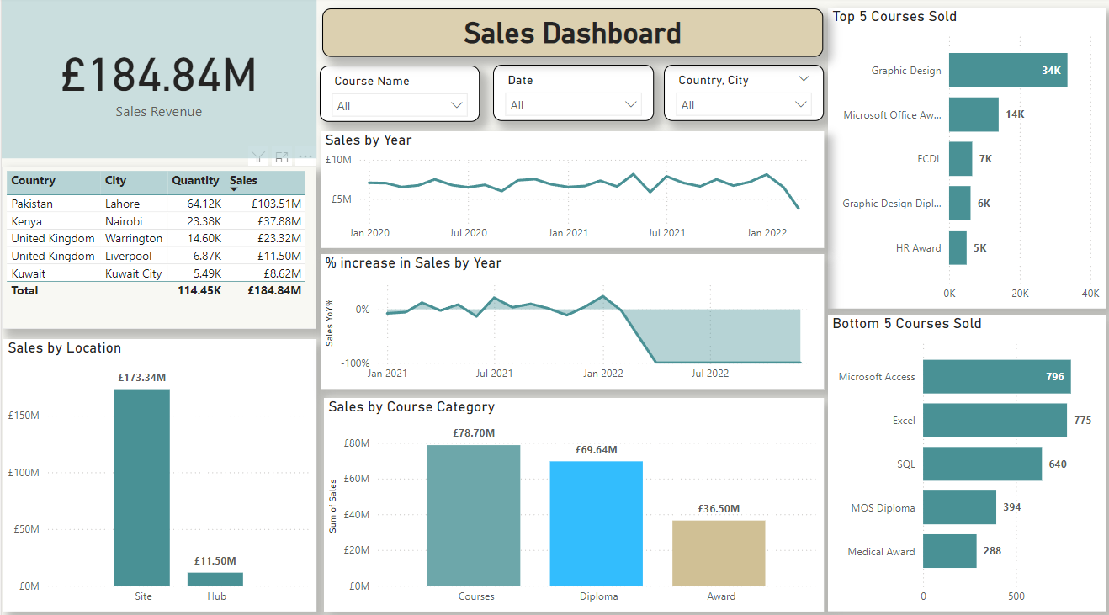
- Sales Revenue: £184.84M.
- Total courses sold: 114.45K.
- Sales location (site/hub): Highest - site (£173.34M), Lowest – hub (£11.50M)
- Top-selling Country (Revenue): Pakistan - £103.51M highest revenue contributor by country.
- Bottom-selling Country (Revenue): Kuwait - £8.62M.
- Sales by year: Mainly steady with small fluctuations through 2020 to 2021 with small fluctuations and decreases -10.36% in 2022 (Data included until March 2022).
- Courses by Category: Highest “Courses” -£78.70M, Followed by “Diploma” - £69.64M and the lowest “Award” category - £36.50M.
- Top Course sold: Graphic Design – 34K.
- Bottom Course sold: Medical Award -288.

FIGURE 5.2 – HR DATA
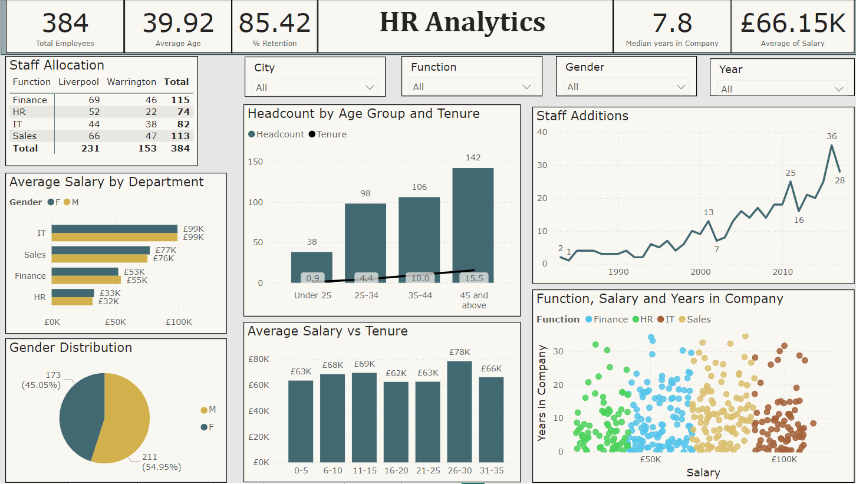
Total number of Employees: 384
Average age: 39.92
Median of years in the Company: 7.8
Retention Percentage: 85.42%
Average Salary: £66.15K
Gender Ratio (Female/Male): 45.05/59.95%
Salary by Tenure: Employees with 26-30 years in the company with the highest average salary (£78K/year). The average Salary of the other tenure ranks varies between £63K and £69K.
Staff Additions: overall increase by year through 1984-2017. In the years 2002,2012 and 2017 the staff additions suffer a significant decreased compared to the preceding year.
Salary by Department: IT is the leading department with an average of £99K Employee salary. Human Resources staff has the lowest average salary £32K.

FIGURE 5.3 – UDEMY MARKET ANALYSIS (2011-2017)
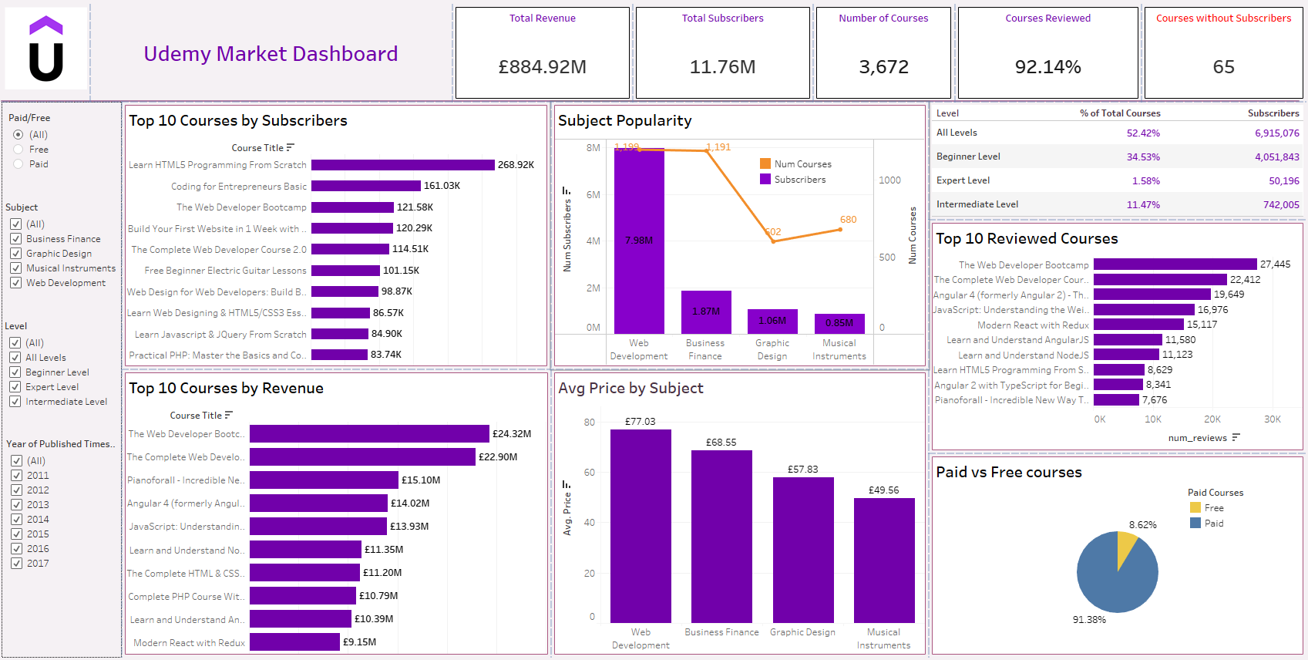
- Total Revenue: £884.92M.
- Total of Subscribers: 11.76M.
- Number of Courses: 3,672.
- Courses Reviewed: 92.14%.
- Courses without Subscribers: 65.
- Course with more Subscribers: “Learn HTML5 Programming from Scratch” – 268.92K.
- Course with more Revenue: “The Web Developer Bootcamp” – £24.32M.
- Most popular Subject: Web Development – 7.98M.
- Average price by Subject: Highest - Web Development (£77.03 ). Lowest – Musical Instruments (£49.56).
- Paid/Free (by number of subscribers): overall 91.38/8.62%.

FIGURE 5.4 – COURSERA MARKET ANALYSIS

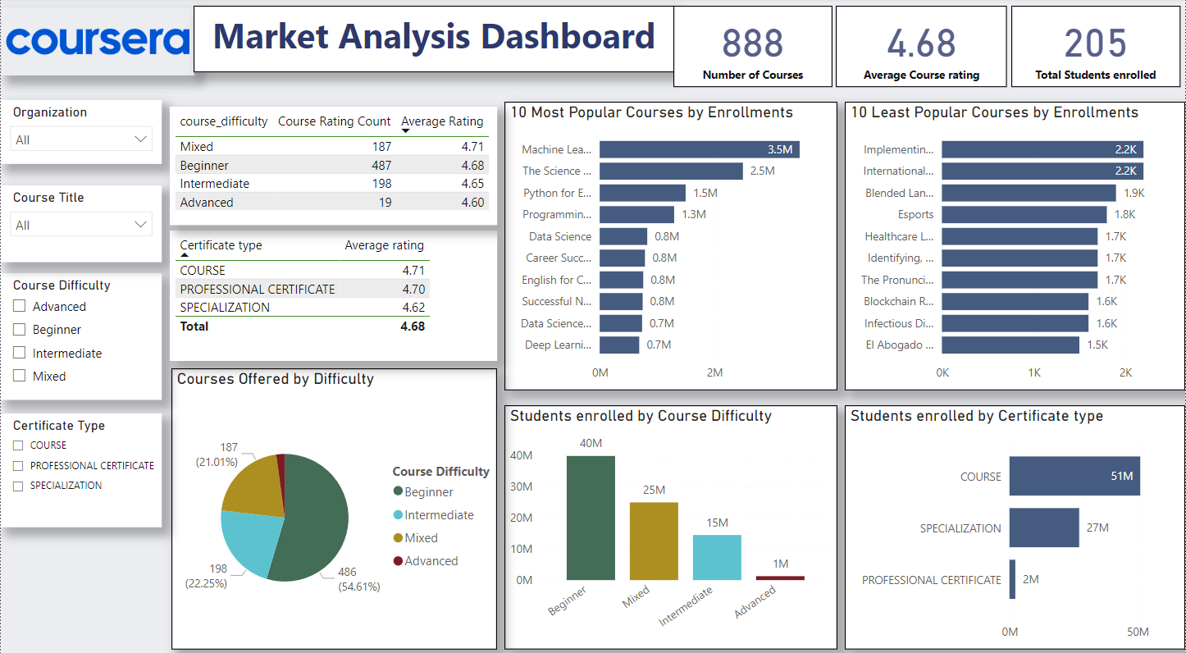
Total number of Courses: 888 - Courses offered.
Average course rating: 4.68(0-5).
Total Students Enrolled: 205.
Courses offered by Difficulty: Beginner courses in the first place (54.64%) followed by intermediate (22.25%) and mixed (21.01%). Being Advanced the one with the lowest number (2.13%).
Students enrolled by Course Difficulty: Beginner courses are the most requested with 40M enrolments. Least requested Advanced - 1M.
Most popular Course: “Machine Learning” – 3.5M of enrolments
Least popular course: “El abogado del future: legaltech y la transformación digital del derecho”. 1.5M of enrolments

FIGURE 5.5 – edX MARKET ANALYSIS

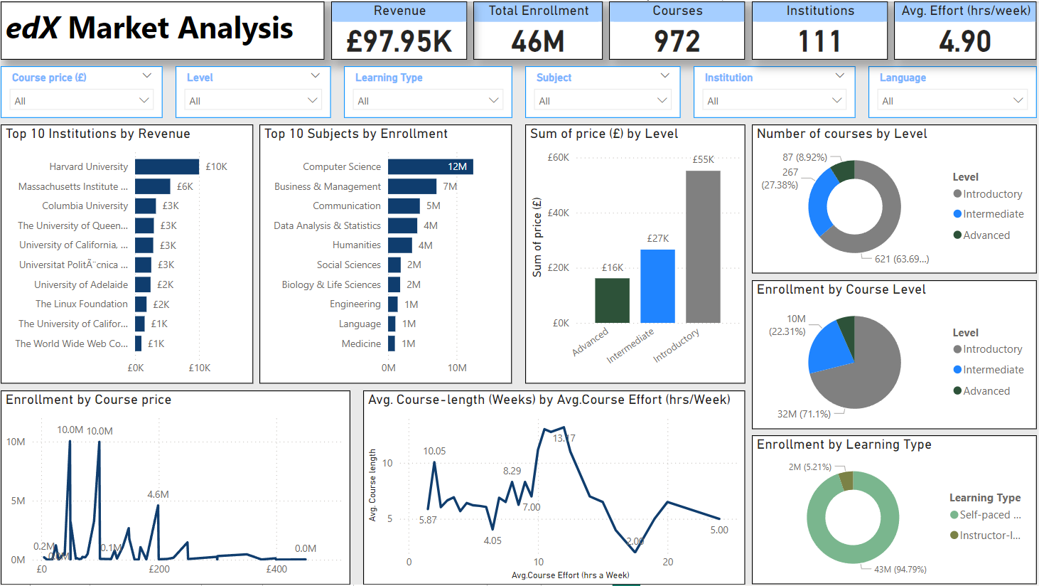
Total Revenue: £97.95K.
Total Enrolments: 46M.
Institutions: 972 - number of institutions offering courses.
Average Effort (hrs/week): 4.90.
Top institution by Revenue: Harvard University - £10K.
Most popular subject (Enrolment): Computer Science- 12M.
Revenue by level: Highest revenue – Introductory (£55K).
Enrolments by course level: Introductory with the highest enrolment - 71.1%
Preferred Learning Type (self-paced/instructor led): Self-paced - 94.79%.

6.0 Critical Analysis and Recommendation:

Areas of Outperformance
Sales Performance (2020–2022)
- Revenue Consistency: Sales have remained steady with minor fluctuations during the analysed period.
- Top-Selling Course: Graphic Design stands out with 34,000 sales, contributing £58.70M to the total sales revenue of £184.84M. It significantly outperforms the second-best-selling course (14,000 sales).
- Key Market:
  - Pakistan generated £103.51M, accounting for over 55% of the total sales revenue.
Market Insights
- Popular Course Categories:
  - Beginner/Introductory courses dominate across platforms (Coursera, Udemy, EdX), representing more than 50% of total enrollments.
  - Advanced/Expert courses show significantly lower enrollment rates.
- EdX Trends:
  - Computer Science courses rank highest in popularity, followed by Business and Management.
  - Enrollment decreases as course prices rise.
  - Self-paced learning is the preferred mode among students.
  - Top Institutions: Harvard University leads with 13M enrollments, followed by the University of Queensland with 2M enrollments.
Total Courses Offered
- Udemy: 11.76M
- Coursera: 888
- EdX: 972
Udemy Subscriber and Price Trends
- Top Courses by Subscribers:
  - Learn HTML5 Programming From Scratch: 268.92K subscribers (most popular).
  - Coding for Entrepreneurs Basic: 161.03K subscribers (less than half the subscribers of the first course).
- Average Price per Course: Varies by subject from £77.03 to £49.56.
  - Web Development: The most expensive subject (£77.03) and the most popular, with 7.98M subscribers.
Areas of Underperformance
Sales Challenges
- Revenue Shortfall: Total revenue falls behind industry leaders, indicating a need for better market penetration.
  - Least-Selling Courses:
    - Medical Award: 288 sales
    - MOS Diploma: 394 sales
  - Underperforming Location: Kuwait generated £8.62M, far below top-performing markets.
Market Analysis: EdX, Coursera, Udemy
- Course Categories:
  - Beginner/Introductory courses attract the highest enrollment, whereas Advanced/Expert-level courses are the least popular.
- Learning Formats:
  - Self-paced courses dominate demand, particularly in Computer Science and Business Management fields.
- Udemy Subscription Trends:
  - 91.38% of subscribers opt for paid courses, compared to only 8.62% choosing free courses.
Recommendations for Improvement
- Enhanced Market Strategies:
  - Leverage data to refine market targeting, especially in underperforming regions like Kuwait.
  - Focus on customer retention by offering personalized learning experiences and loyalty programs.
- Course Offerings:
  - Expand beginner-level course offerings to tap into the most active market segment.
  - Reevaluate the pricing strategy for Advanced/Expert courses to boost enrolment.
- Partnerships and Marketing:
  - Strengthen partnerships with leading institutions to mirror the success of Harvard and the University of Queensland.
  - Invest in digital marketing campaigns targeting self-paced learners and Computer Science enthusiasts.

7.0 Conclusion:

This data analysis report highlights significant trends, insights, and areas for improvement across the analyzed datasets. Key findings from sales performance reveal steady revenue with notable growth in specific regions and categories, while the HR analysis sheds light on workforce dynamics, including salary distribution and retention rates. Furthermore, the market analysis of online course providers such as Udemy, Coursera, and edX uncovers consumer preferences, enrollment trends, and course performance. Based on these insights, several recommendations have been made, including enhancing market targeting in underperforming regions, expanding beginner-level course offerings, and refining pricing strategies. Overall, this analysis provides valuable recommendations that can drive informed decision-making, improve organizational performance, and guide future strategies.
Challenges Faced and Limitations
Balancing project tasks alongside learning on DataCamp and working full-time presented a significant challenge. It required effective time management and unwavering dedication, as the process demanded fast-paced learning and consistent daily effort.
The project also encountered several issues related to data quality and consistency. The sales dataset was incomplete, with the most recent record dating back to March 2022. This limitation resulted in inaccuracies in the final reports and figures. Additionally, other datasets required the creation of new metrics and extensive data cleaning to enable subsequent analysis. These tasks increased the overall time commitment and necessitated further research.
Way forward
To address the challenges and capitalize on the insights gained, the following steps are recommended: Enhanced Market Strategies Utilize data analytics to refine market targeting, with a particular focus on underperforming regions such as Kuwait. Prioritize customer retention by introducing personalized learning while ensuring competitive pricing. Expand the portfolio of beginner level courses to attract the most active segment. Reassess the pricing strategy for Advanced and Expert courses to encourage greater enrolment and accessibility.
Finally, invest in strategic marketing campaigns to amplify brand visibility and establish credibility in new and existing markets.
By implementing these initiatives, the organization can enhance its market position, improve customer satisfaction, and achieve sustained growth.

